The Annual Children’s Fund

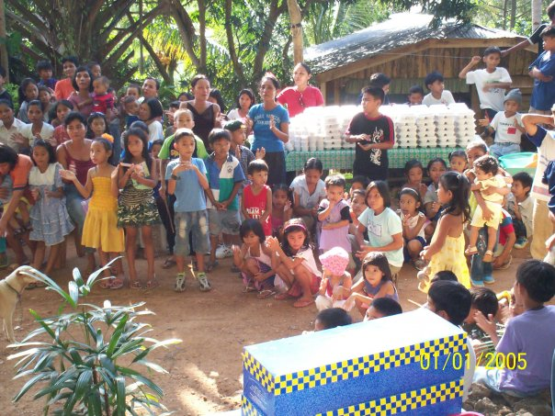
Greetings!
It is now the 8th year of our Annual Malasag Children’s Fund. Through your continued support, over the years, we have been able to help the under-privileged elementary and high school children of the hilly community of Malasag, the value of educating Filipino people has always been close to my heart since its conception way back during my university days.
Aside from helping the children, we also plan to facilitate the improvement of the schools' audio/visual facilities and upgrade their computer technology. We always mark the culmination of this event with a Filipino-style Christmas Party, marked by games, winning prizes, food sharing and gift-giving (i.e., school bags, slippers, clothes and school supplies). This is why, as early as now, I am once again knocking on your generous hearts to continue supporting this worthy cause. In the wake of Typhoon Haiyan (Yolanda) that wrecked the Visayas, I enjoin you to be extra kind and generous this year as we will be also be extending our help to the people of Leyte. We will be teaming up with other individuals who are willing to share their knowledge and expertise in education, psychology, medical, and the arts, while others will be volunteering in building new houses to a community we have selected. We plan to help and adopt a small community, rebuilding their lives and supporting them in gaining back their lost livelihood.

The Annual Children’s Fund

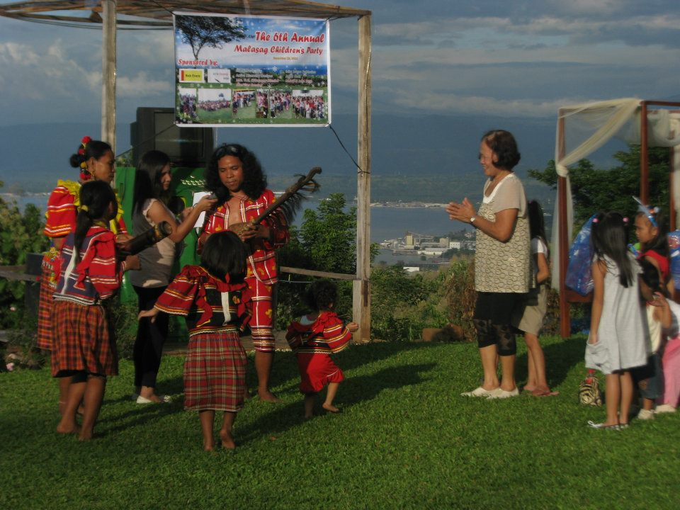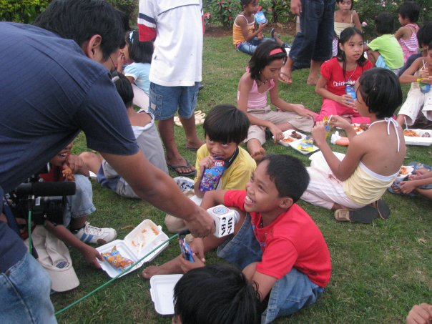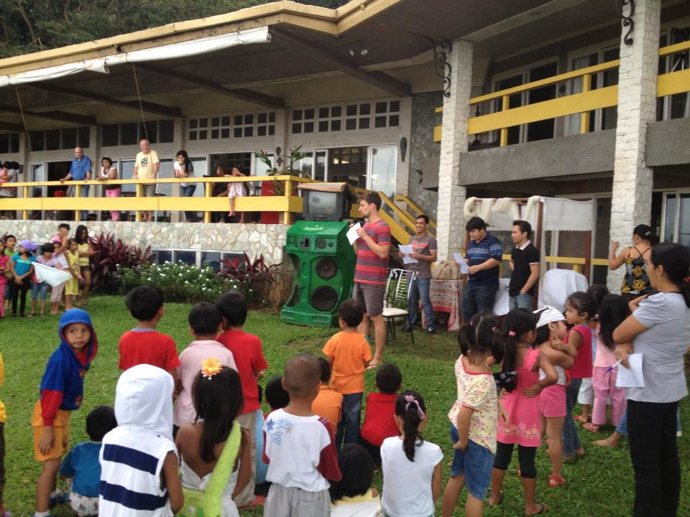

This is my little way of giving back to the community and the country that has embraced, nurtured, and blessed me with having great friends and meeting new people. Together with your unfailing support, allow me to help bring back the smile of the people who lost everything and support these children to create and be a part of a much better society.

